# loc and iloc (2) - Corrected

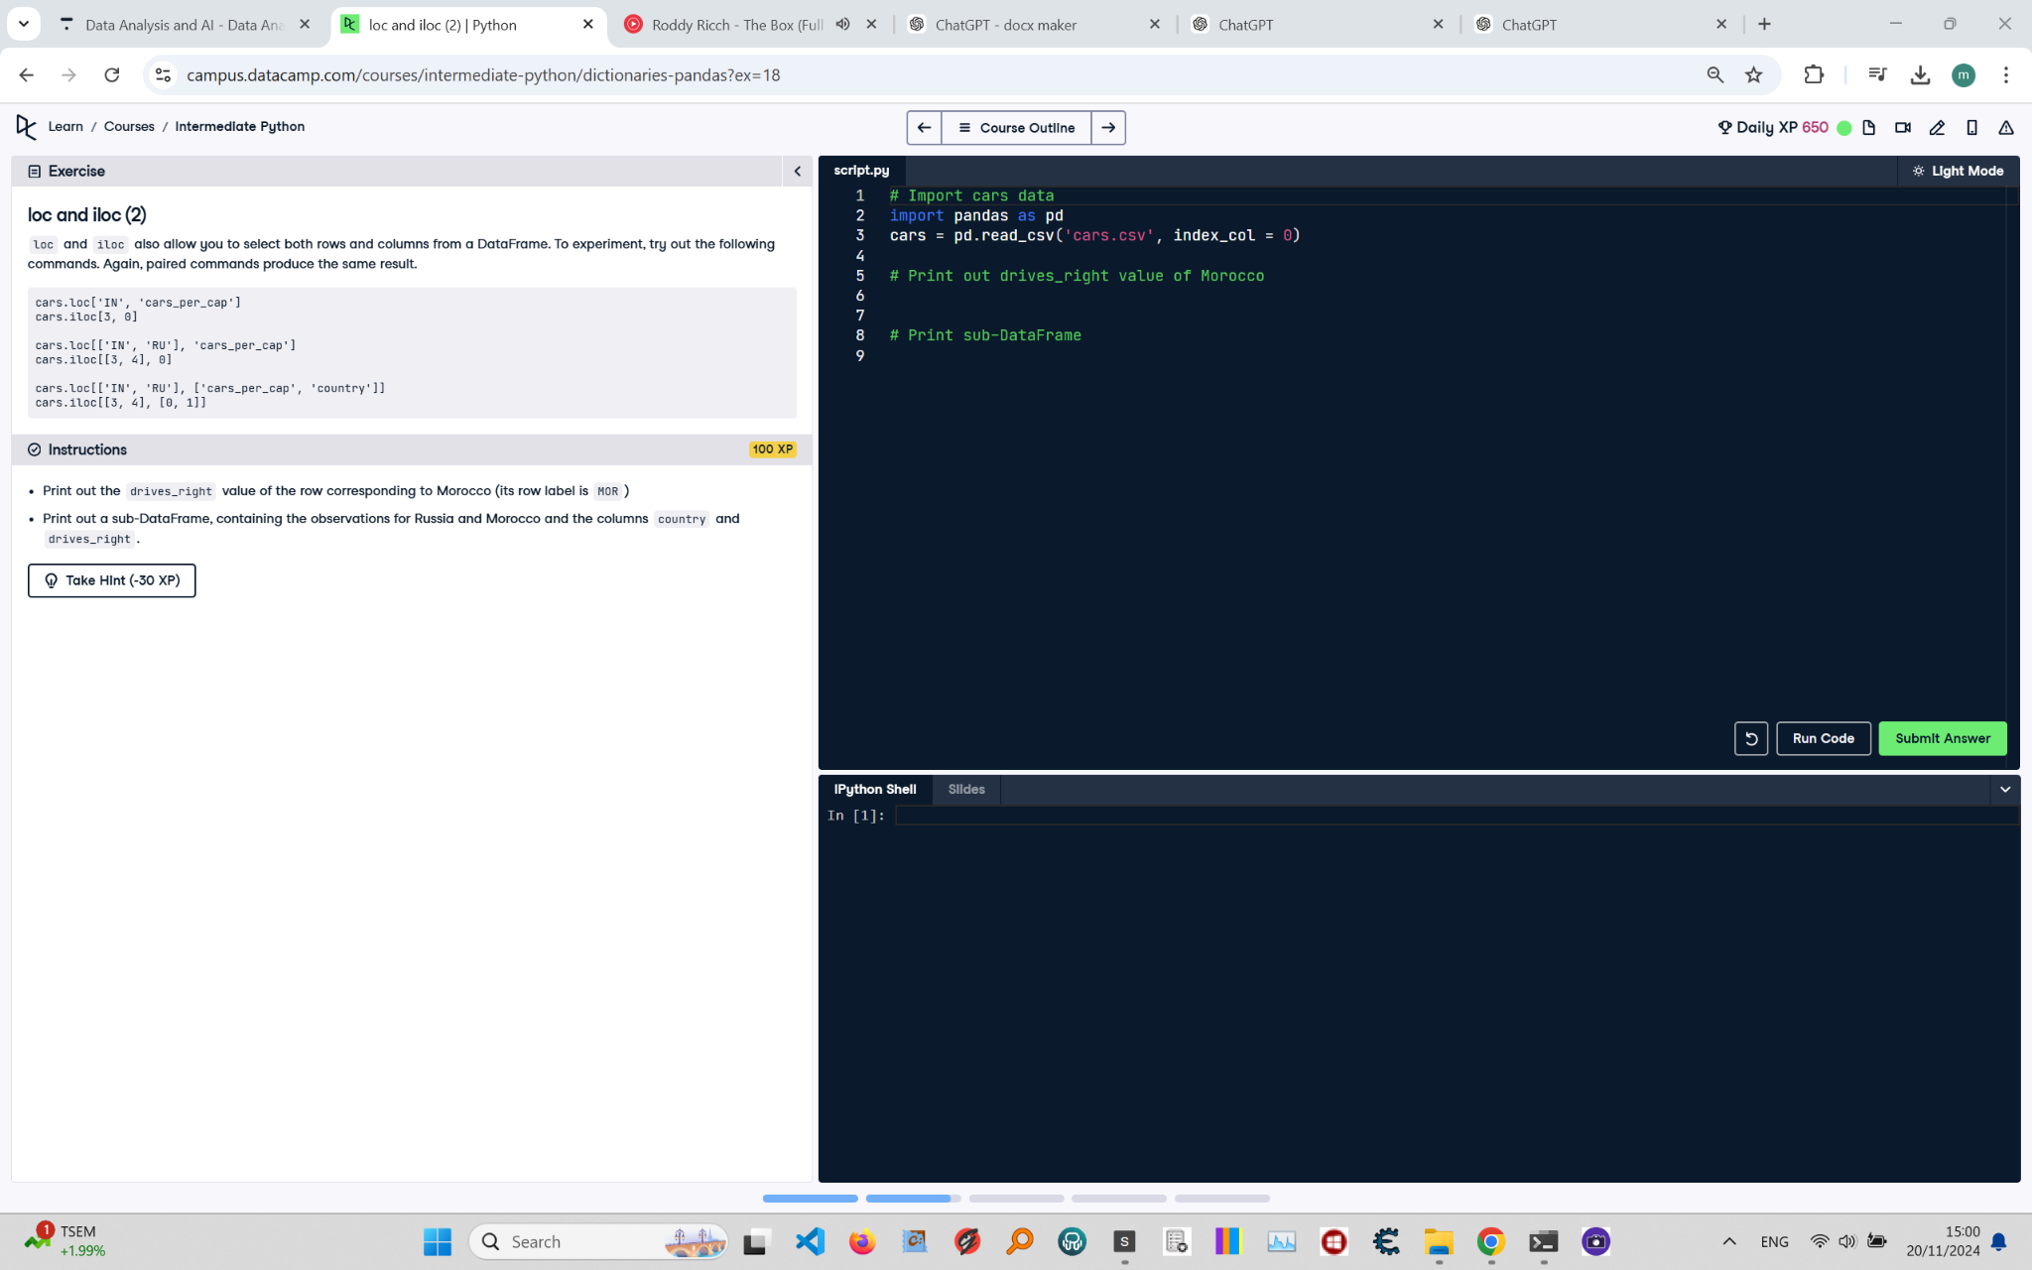

## Question:

Print out the drives_right value of the row corresponding to Morocco (its row label is MOR).  
  
 Print out a sub-DataFrame, containing the observations for Russia and Morocco and the columns country and drives_right.

## Answer:

## # Import cars data

## import pandas as pd

## cars = pd.read_csv('cars.csv', index_col = 0)

## # Print out drives_right value of Morocco

## print(cars.at['MOR', 'drives_right'])

## 

## # Print sub-DataFrame for Russia and Morocco, columns country and drives_right

## print(cars.loc[['RU', 'MOR'], ['country', 'drives_right']])

## Code Explanation:

1. `import pandas as pd`: Imports the pandas library for data manipulation and analysis.  
 2. `cars = pd.read_csv('cars.csv', index_col=0)`: Reads the 'cars.csv' file into a pandas DataFrame and sets the first column as the index.  
 3. `print(cars.at['MOR', 'drives_right'])`: Uses the `at` method to access the 'drives_right' value for the row labeled 'MOR' (Morocco) efficiently.   
 It is more optimized for accessing a single value compared to `loc`.  
 4. `print(cars.loc[['RUS', 'MOR'], ['country', 'drives_right']])`: Uses the `loc` method to select rows labeled 'RUS' (Russia) and 'MOR' (Morocco) and restricts  
 the columns to 'country' and 'drives_right', then prints the resulting sub-DataFrame.  
 Ensure the row labels ('RUS' and 'MOR') exist in the DataFrame, or this line will throw a KeyError.